**Introduction para:** Two genetics studies using Restriction-site Associated DNA sequencing have indicated significant genetic differentiation among spawning stocks of Pacific cod in the GOA and the EBS (Drinan *et al.* 2018; Spies *et al.* 2019). High assignment success (>80%) was demonstrated among five spawning populations of Pacific cod throughout their range off Alaska using 6,425 single-nucleotide polymorphism (SNP) loci (Drinan *et al.* 2018). Further work using 3,599 SNP loci and spawning samples throughout the range of Pacific cod off Alaska, as well as a summer sample from the Northern Bering Sea in August 2017 showed significant differentiation among all spawning groups (Spies et al. 2019). The three spawning groups examined in the GOA, Hecate Strait, Kodiak Island, and Prince William Sound, were all genetically distinct and could be assigned to their population of origin with 80-90% accuracy (Figure 2.2; Drinan *et al.* 2018). There was strong evidence for selective differentiation of some loci, including one that aligned to the zona pellucida glycoprotein 3 (ZP3) in the Atlantic cod genome (Drinan *et al.* 2018). This locus had the level of differentiation of any locus examined (FST=0.071). ZP3 a reproductive protein that is known to undergo rapid selection, and it has been shown to neofunctionalize as an antifreeze protein in Antarctic icefishes (Spies *et al.* 2021). At the putative ZP3 locus in Pacific cod, a distinct set of haplotypes have been observed in spawning cod from Kodiak Island westward vs. Prince William Sound and samples to the east. Results were consistent with directional selection in the Bering Sea (Bering Sea, Aleutian Islands, Shumagin Islands, and Kodiak Island), and large regional differences among ZP3 haplotype frequencies between the Bering Sea group and other spawning locations in the Gulf of Alaska and further south, including Prince William Sound and Hecate Strait. Results were also indicative of selection currently acting on northern collections, as may indicate local adaptation driven by differences in ZP3.

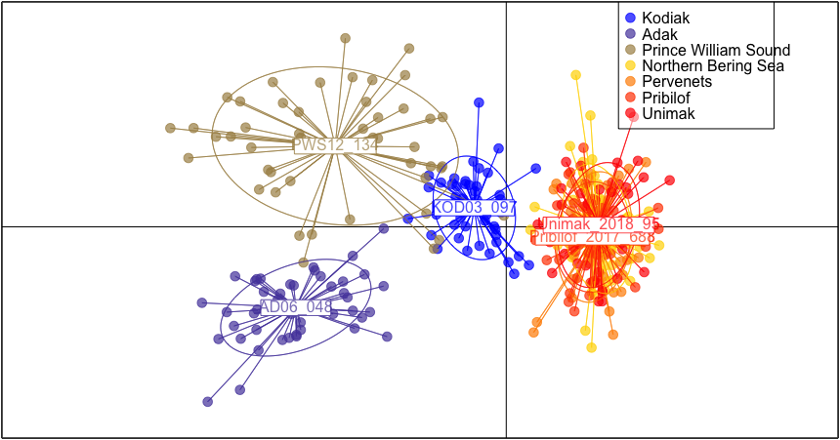

Figure 2.2. Discriminant analysis of principal components (DAPC) scatterplot with the following populations represented: Adak (2006), Prince William Sound, PWS (2012), Kodiak (2003), Unimak (2018), Pervenets (2016), Pribilof (2017), and Norton Sound, NBS (2017). All populations represent spawning groups except the Norton Sound sample, which was sampled in August, 2017. Note: The Norton Sound sample in panel b. is behind the Unimak and Pribilof labels, and barely visible (Spies et al. 2020).